**Jonathan Turing**, Mobile Developer

India

Professional Summary

Mobile Developer, specialized in Android applications. Working in the tech industry for the last 4 years, working with Android, Kotlin, and Java. Experienced in iOS development, building Native Apps on Swift and Objective-C. Enjoy designing scalable and clean code in a fast environment.

**Work History**

**Role**  Start date - Present

Company

Project #1

Overall description of the project

* Responsibilities and role
* Hands-on description of your performance
* Explaining the technology you used and how you used it
* Cross-team collaboration, and highlights

Outcome

How successful this project was.

Software Development Skills you used

### **Business Analyst Intern**

Accenture April 2019 - November 2019

Instagram

**https://play.google.com/store/apps/details?id=com.instagram.android**

* Business Analytics intern responsible for supporting project leadership in data extraction and analysis for a large client in telecommunications.
* • Ensure correct submission of daily reports via Excel.
* • Extract data via SQL and perform analysis via Excel that supports decision making.
* • Actively participate in weekly status meetings.
* • Conduct analysis requested by the client.
* • Collecting and interpreting data.
* Analyzing results.
* Reporting the results back to the relevant members of the business.
* Identifying patterns and trends in data sets.
* Working alongside teams within the business or the management team to establish business needs.
* Defining new data collection and analysis processes.
* As a senior data analyst, responsibilities include collecting data, organizing that data.
* And then analyzing the data to accurately report findings for other departments to make informed decisions.
* Also overseeing and mentoring a small team and serves as a liaison between the data analysts and other departments.
* Tech stacks used: Excel, Excel VBA, MySQL, SQL, Power BI.

Outcome:

Successfully deployed the applications within the timeframe. Made updates according to feedback. Have received great feedback from users and stakeholders. Currently supporting 1+ Billion users.

Android Kotlin Mobile App Development Java

Screenshots:

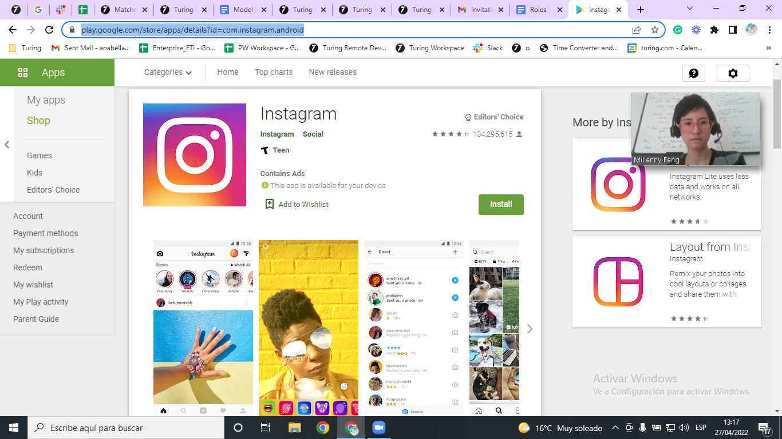

**Web Developer**

Freelance Experience January 2018 - June 2018

Canva Website  
**https://www.canva.com/**

• Coded and designed Canvas website using HTML, Angular, and CSS technologies.

**•** Assisted with the maintenance and upkeep of the website.

**•** Created the front-end using React, JavaScript, and Vue.js.

**•** Implemented scripting and authoring languages, management tools, content creation tools, applications, and digital media.

**•** API design was also developed.

**•** Developed an application available for Android and iOS devices.

Improved user-experience and deployment. The website has more than 7 million users and downloads.

Android Vue.js Anguar CSS JavaScript React Website Development HTML

Screenshots:

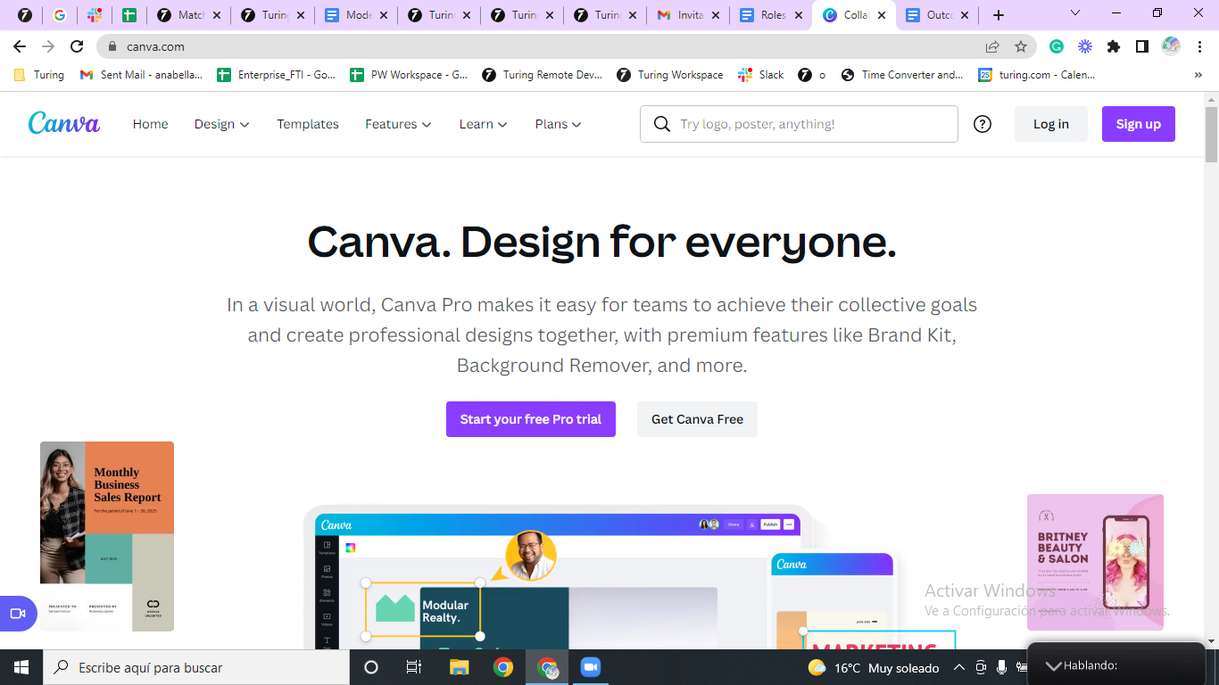

### **Education**

September 2014 - December 2020

### **University of Nairobi**

BE in Electrical and Electronics Engineering